# **Eclipse Setup Guide**

## Eclipse OSGi enterprise support (optional)

Another optional, but useful set of plug-ins for EniwareNetwork development in Eclipse are from [Project Libra](https://www.eclipse.org/libra/). Navigate to **Help > Install New Software...**, select the project release update site URL in the **Work with** menu (for example http://download.eclipse.org/releases/oxygen if you're using Eclipse Oxygen) and look under **Web, XML, Java EE and OSGi Enterprise Development** for these plug-ins:

* OSGi Bundle Facet
* OSGi Frarmework Editor
* OSGi Framework Launchers

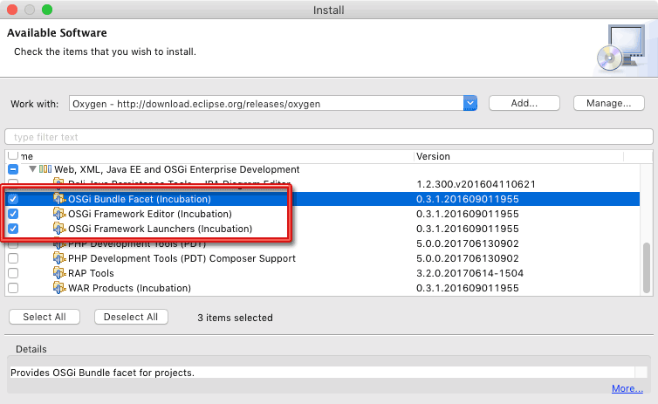

Open a GIT Perspective: **Window>>Perspective>>Open Perspective>>Other>>Git**

In the top right corner of Eclipse window you will see the icon of GIT Perspective.

After you open the GIT Perspective you need to Clone the Repository’s from Github.

Clone the repository to your Eclipse in GIT Perspective.

Address: <https://github.com/eniware-org>

5 repository’s

* + - * org.eniware.build - <https://github.com/eniware->org/org.eniware.build
      * org.eniware.common-https://github.com/eniware-org/org.eniware.common
      * org.eniware.edge- https://github.com/eniware-org/org.eniware.edge
      * org.eniware.external- https://github.com/eniware-org/org.eniware.external
      * org.eniware.central- <https://github.com/eniware-org/org.eniware.central>

Copy the address from Github:

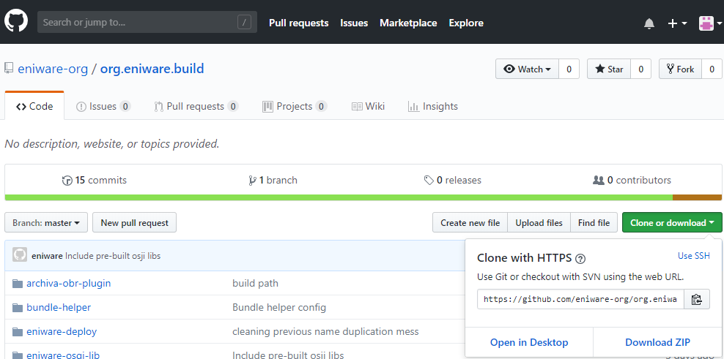

To clone the repository switch to GIT Perspective and click to this icon.

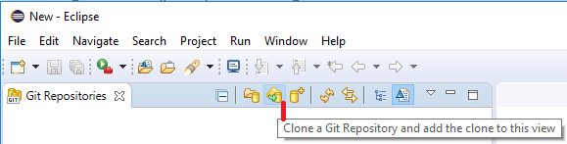

And paste the link from Github :

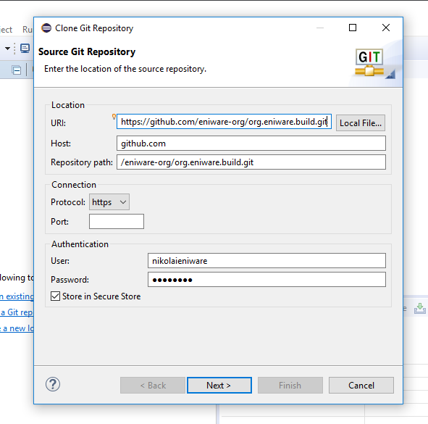

Then Click Next to Select the branch

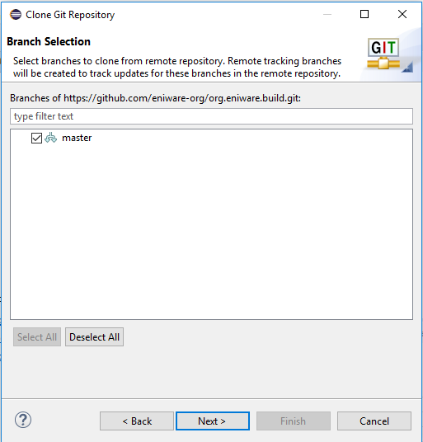

Click again Next. In the next window you have to choose the local destination, also you can click to the red circle and mark the square to Import all existing Eclipse project after clone finishes.

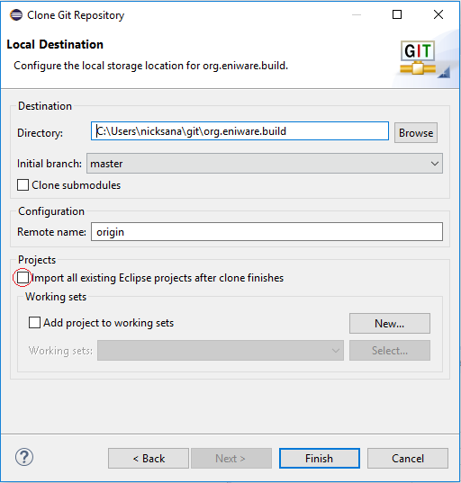

After you clone all 5 repository to your Eclipse switch to Java Perspective and look all projects. It should be look like this:

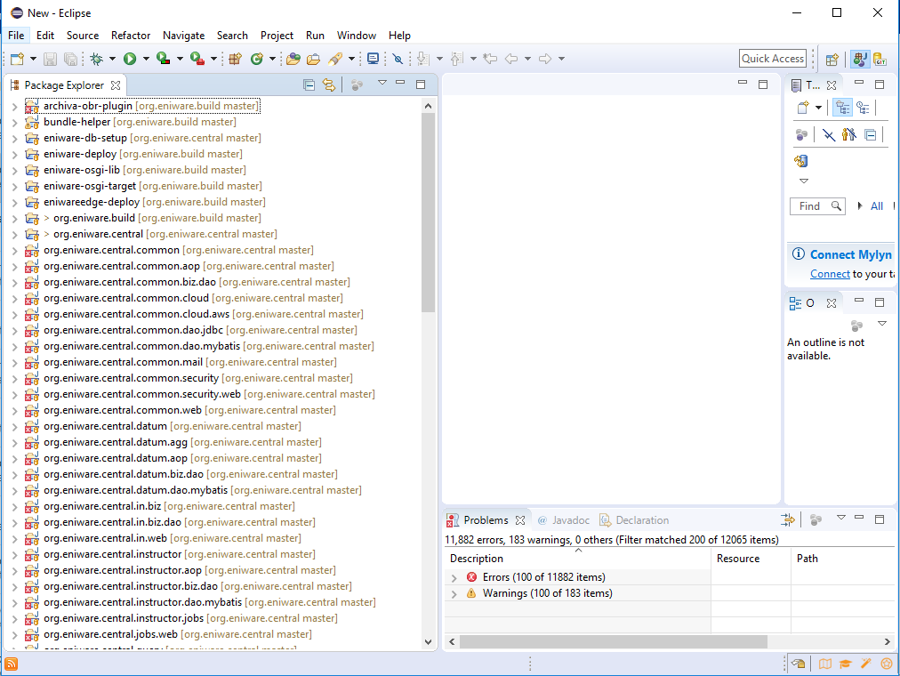

We have to configure the Eclipse. This will happened in few steps.

Open project **eniware-osgi-target** then open folder **defs** then doble click on **org.eniware-gemini.target .**

After that you have to **Set up the target platform** with button **Set as Active Target Platform**

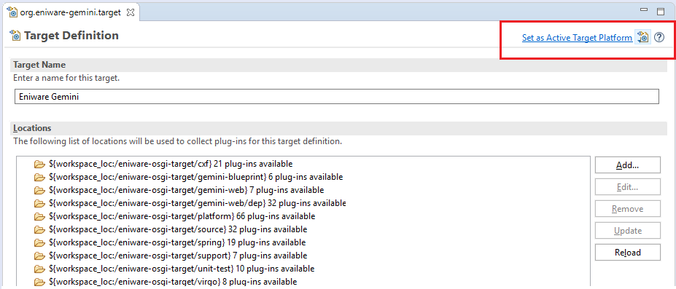

This will create and activate the Eclipse target platform, and all Eclipse errors for all projects should go away. If any errors remain, select those projects and choose **Project > Clean...** to have Eclipse re-compile those projects again. Sometimes Eclipse incorrectly reports problems, and cleaning those projects will resolve the errors. You will find references to this situation on the web called *"the Eclipse dance."*

Click on the **Environment** tab at the bottom, then under the **Arguments** section select **VM**. Select this entire block of text and copy it, as you'll need to paste this into the runtime configuration, discussed in the next section.

Configure OSGi Runtime

In order to run the EniwareNetwork platform within Eclipse, you must configure the OSGi runtime environment. First, create the directory /eniware-osgi-target/config. Then copy all the files from /eniware-osgi-target/example/config into that directory.

Next go to **Run>>Run configuration**

From Run configuration choose OSGI Framework

Specify **EniwareNetwork** as the runtime name.

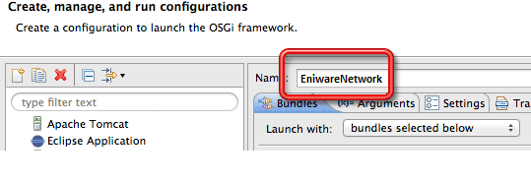

Next, you must change some of the start levels for a handful of bundles, to ensure the platform can start up correctly. Modify the start levels of the bundles to the following:

|  |  |
| --- | --- |
| Plugin | Start Level |
| org.apache.felix.eventadmin | 1 |
| org.apache.felix.fileinstall | 2 |
| org.apache.servicemix.bundles.derby | 1 |
| org.eclipse.equinox.cm | 1 |
| org.eclipse.gemini.web.extender | 5 |

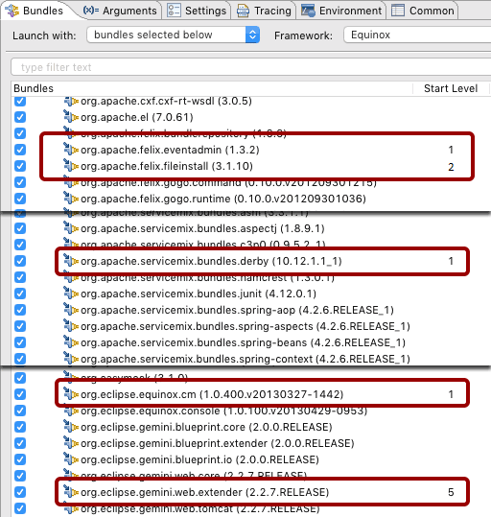

Next, click on the **Arguments** tab and change the **Working directory** to **Other** and specify ${workspace_loc:eniware-osgi-target} as the path. In the **VM arguments** section, paste in the arguments you copied from the target platform configuration in the previous section, which should look something like

-Dsn.home=${workspace_loc:eniware-osgi-target}

-Dderby.system.home=${workspace_loc:eniware-osgi-target}/var/db

-Djava.util.logging.config.file=config/jre-logging.properties

-Dosgi.java.profile=file:config/java6-server.profile

-Dorg.apache.felix.eventadmin.Timeout=120000

-Dfelix.fileinstall.dir=configurations/services

-Dfelix.fileinstall.filter=.*\.cfg

-Dfelix.fileinstall.noInitialDelay=true

-Declipse.ignoreApp=true

-Dosgi.noShutdown=true

-Dxml.catalog.files=${workspace_loc:eniware-osgi-lib}/xml-catalog/catalog.xml

Next, click on the **Settings** tag and change the JRE to use the **Execution environment** value of **JavaSE-1.6**.